

Social Media policy and guidelines

Document date: February 2011
Document owner: Ben Whitehouse, Digital Communications Manager

What is social media?

'Social media' is a term used to describe web services and tools that allow you to interact with others in the sharing of information, opinions and content. Some of the most popular examples of services are Twitter, Facebook, Flickr and YouTube as well as more generic activities like blogging. With social media, the emphasis is very much on building communities of interest and encouraging people to participate, even in small ways such as rating content or commenting on blogs.

JISC staff and social media

JISC staff are encouraged to engage in social media activity. Conversations about JISC and its work are taking place in the social media space and it is important that JISC contributes to the debate. It is a great opportunity to engage with stakeholders in a personal and informal way, to correct misinformation and increase the impact and understanding of JISC’s work.

Participating in social media in a work-context is voluntary and requires an investment in time and an understanding of the social media environment to ensure maximum benefits to JISC staff and their area of work.

The blurring of work and personal space is a feature of social media. Whilst the use of social media can help build relationships with stakeholders, it can also sometimes cause problems or conflicts of interest when personal posts are at odds with or critical of JISC, are associated with JISC or mistaken for the official position on an issue. To avoid this occurring, we recommend that JISC staff keep separate profiles for work and social use.

JISC staff should maintain the same high standards of professional behaviour that is expected of them in other public fora and avoid any activity that could bring JISC or its work into disrepute.

About this document

This Social Media policy and recommendations are intended as a guide to engaging with social media as a JISC member of staff.

These guidelines are not intended to control personal use of social media services, but are an attempt to create an environment that allows users to operate in their own best interests, as well as that of JISC.

Policy

1 You’re personally responsible Write in the first person ('I think...'). These are your opinions, no one else’s, and you take personal responsibility for them.

If you identify your employment with JISC and regularly post on work-related matters or the activities of JISC in a public forum, you will be associated with and be an ambassador for JISC whether you intend to be or not. When discussing JISC or its activities, always identify yourself by name and your role within the organisation. Be clearly identifiable in the communities in which you engage.

Ensure you use the following disclaimer when writing about work-related matters as readers will assume you are expressing the views of JISC:

These are my personal views and opinions and not those of JISC

Be aware that anything you post in a public space will live there for a long time and may be copied, re-purposed and redistributed in different contexts from the one in which it was posted.

Don't fire off posts in anger or frustration. Don’t say something in a social media space that you wouldn’t say face-to-face. Consider what you have written carefully before posting and, if you have any doubts, don't post it, come back to it later or ask a colleague to check it.

2 Be respectful The law still applies. Don't be fooled by the informal nature of social media; laws such as libel, defamation, equality and data protection still apply. Be careful what you say and how you say it. Use of a disclaimer will not protect you if you break the law. If in any doubt, don't publish or seek appropriate legal advice.

3 Protect privacy Your own, others and that of JISC. Do not publish contact details or quote private conversations (verbal or electronic) without seeking permission. Do not post confidential corporate information such as draft policies, bids in progress, funding situations, embargoed reports and news releases, or internal emails in a public forum. If you are in any doubt, please consult your line manager.

4 Respect copyright If you are posting, adapting or using content created by someone else, make sure you have copyright clearance, use appropriate referencing and citation, and link to content where possible.

5 Press or media engagement When talking with journalists via Twitter, Facebook or other social networks, treat their query just as you would any other media call and contact the JISC Press Office at press@jisc.ac.uk

Any questions?

Please contact the JISC Communications Support team communications@jisc.ac.uk.

Best practice guidelines

• Be where your audiences are. Choose the social media spaces your audiences use and choose your networks carefully.

• Set clear aims and objectives. What do you or the organisation you work for want to get out of communicating through social media? What are the benefits?

• Be open and honest. Don't try to control the 'message'. Admit your mistakes and reflect on them. Do not try to bluff people - you will be found out and exposed.

• Write about what you know. You add value by contributing your views and opinions on topics you know something about. You can potentially damage JISC’s reputation by posting on subjects where you are not an expert or are not aware of all the facts.

• Stay interesting and relevant. Think about the interests and concerns of your audience. Refer to JISC’s guidance on writing for the web.

• Be constructive. People are going to disagree with what you say and may express that in many ways, from the helpful to the downright rude. Rise above it and ensure your engagement is constructive and positive. Remember, some comments are not worthy of a response.

• Adopt an informal, conversational style. Social media is a chance to engage with people on a personal level, as if you were talking to them at a conference.

• Keep it short and sweet Posts don't need to be long. In fact, it's sometimes better if they aren't.

• Be generous with links Links are an essential part of blogging. Consider where a link could add value to your post for the reader: think places, people, organisations, news stories, other blogs, definitions.

• Provide timely responses. If you post to the social web, it is not going to be long before someone replies and expects a response in return. You may sometimes need to reflect on what others have written or look something up but try to provide a response in a timely manner. You don't need to respond individually to every comment. If you receive a lot of comments all on the same theme, you could post one response, maybe making reference to some of the comments.

• Publish regularly and frequently. By setting up a social media presence you are committing to update it regularly. If a social media space is not being kept up to date it may be better to archive it or possibly remove it. If you are posting in a corporate social media space ask colleagues if they would be interested in either contributing or becoming the owner of the space. Ensure there is a secondary contact for your social media presence in case you are away for any extended period.

• Be aware of other people’s use of social media. Do not assume that Chatham House Rule applies – an ‘off the record’ remark at a meeting or event (formal or informal) may be personally attributed to you and redistributed multiple times via social networks within seconds.

• Monitor your social media activity Use Google analytics and other tracking software to gauge readership and keep track of RSS subscriptions, followers or other useful measures. Monitor posts on your site regularly to check for spam or abuse.

• Do not remove offensive or derogatory comments from the social media space. Report them to the site administrators immediately.

• Respond to negative posts carefully Ask yourself… can I answer this with factual information and without an emotional response? Do I have the knowledge to respond? Does it need a response or is it a rant? Sometimes ranters just need to rant and in these cases it is best not to respond. If in doubt, consult your line manager.

• Not all social media services are suitable for hosting JISC content Users should always read the terms and conditions of service as some clauses may contradict JISC’s policies eg. IPR (claiming copyright for any content posted on the site). Reporting tools which measure impact and ROI on communications activity may not be available (eg. number of page views, downloads).

JISC’s social media presence

Twitter | http://twitter.com/jisc
YouTube | http://www.youtube.com/user/JISCmedia
Vimeo | http://vimeo.com/jisc
Flickr | http://www.flickr.com/photos/jiscimages/
Slideshare | http://www.slideshare.net/JISC
Delicious | http://www.delicious.com/JISC
iTunes | http://itunes.apple.com/gb/podcast/jisc-podcast/id264337022
issuu | http://issuu.com/jisc

Wikipedia
Responsibility for monitoring and maintaining JISC’s Wikipedia entry http://en.wikipedia.org/wiki/jisc lies with the JISC Press and PR team. Decisions regarding separate Wikipedia entries for specific areas of JISC’s work rests with the JISC Press and PR team. Anyone setting up a Wikipedia entry is responsible for monitoring and maintaining the entry throughout its life-cycle.

JISC Involve blog
JISC Involve is a blogging platform using WordPress and is provided by JISC and therefore any posts are considered to be associated with JISC. To set up a JISC Involve blog, contact web@jisc.ac.uk.

Twitter
JISC staff use Twitter to engage and join in conversation with stakeholders. JISC has a Corporate Twitter account which is fed by RSS feeds of JISC news, events, podcasts and funding opportunities. Occasionally JISC Communications & Marketing use it to provide status updates on web services or for getting feedback on new developments. To set up your own Twitter profile visit www.twitter.com. If you are referencing JISC’s work use the tag: #jisc

Dorothy Bishop, professor of psychology at Oxford, has written an introduction to tweeting for academics which will also be relevant to JISC staff about to embark on posting to blogs or Twitter.

Content sharing services

JISC has traditionally made digital media, such as Powerpoint slides or videos, available for download from its website. It now also supports a JISC corporate presence on:

  - YouTube (for video shorts)
  - Vimeo (for feature-length video)
  - Slideshare (for slides)

If you would like your content to be considered for these channels, please contact web@jisc.ac.uk.

Principles of content creation and publication

- When making digital media available on the web, JISC will look for popular and suitable content sharing services on which to host this content via a JISC 'channel';
- Not all services will be suitable for hosting JISC content. It is essential to always read the terms of conditions of any site and to analyse the benefits and risks before making a decision to proceed. Particular areas to note:
  - restrictive IPR conditions e.g. claiming copyright for any content posted on the site;
  - the reporting tools available i.e. number of page views, how often videos are embedded elsewhere etc. JISC still needs to measure impact and ROI of its activities.
- Because of the speed with which content can be posted to these sites and user expectations about this, posting content on these services will be considered a priority over making the content natively available for playing and/or downloading from the JISC website;
- However, content must always be made available for playing and/or downloading from the JISC website, for resiliency, accessibility and archiving purposes. This is considered the primary content, although please provide links to third party sites so that users know the content is also available there (users may prefer to consume the content that way);
- Standalone players will always be used on the JISC website, rather than embedding players from third party sites, to provide resiliency in the event of third-party service downtime.
- Any links within JISC web pages (i.e. news story about a video) must always be to the primary content hosted on the JISC website, not to third party sites.

Obligations and responsibilities
There are a number of obligations that fall upon JISC (and the Comms team in particular) when making digital media available in this way:

- Content must be clearly branded and identifiable with the JISC logo (see the JISC brand guidelines) as it could be repurposed in contexts far removed from the original one.
- As the content can be freely used and repurposed, permission from any third-party IPR rights holders (e.g. interviewees in a video) must be received before the content is made available.
- Wherever possible, the content should be made available under a Creative Commons Attribution-Non-Commercial-No Derivative Works 2.0 UK: England & Wales licence (JISC IPR policy) and the licence terms should be explicitly stated within the content itself (verbally or visually), not just on the web page that contains or links to the content. The copyright licence should also be displayed on the web page itself in human-readable form, and machine-readable form if possible (eg. by use of RDFa)
- Content posted on sharing sites can be rated and commented on by users and JISC needs to enter into this conversation. This means that when JISC projects and programmes produce multi-media and social media content they are responsible for providing responses to comments. The JISC PR team and/or Communications Managers may wish to co-ordinate and provide responses for high-profile content items or offer advice on contentious or negative comments.

Further reading
- Intel social media guidelines
- IBM social computing guidelines
- CIPR social media guidelines
- Devon County Council policy and guidelines
- UKOLN Briefing Documents on Blogs and Blogging

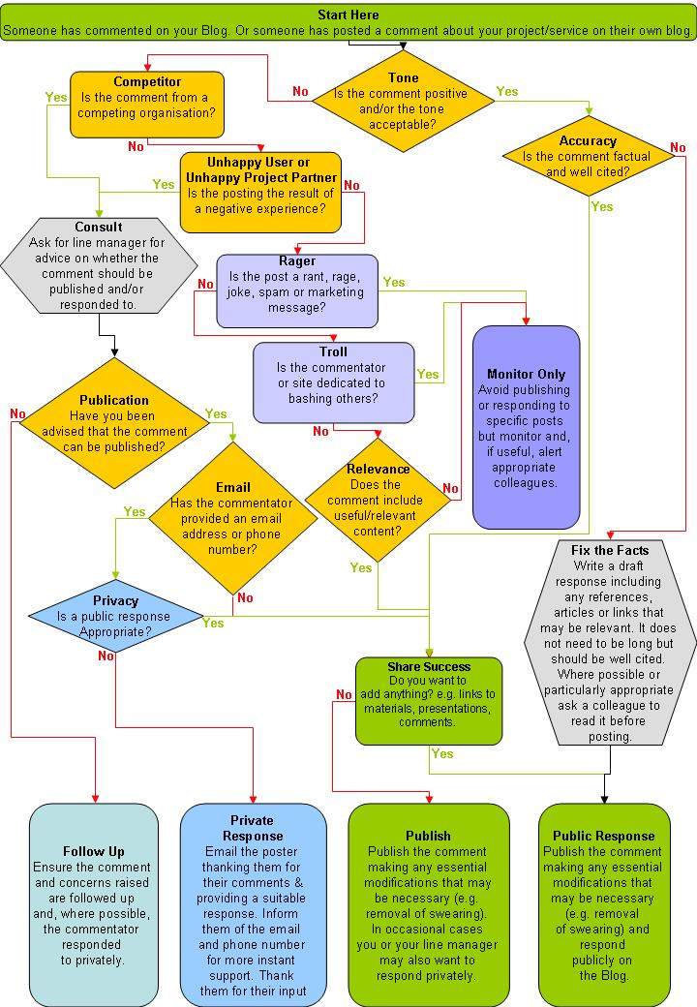

This diagram was produced by Edina and is licensed under a Creative Commons Attribution-ShareAlike 3.0 Unported License: http://creativecommons.org/licenses/by-sa/3.0/

